- Order Type.
To allow ops to register/change order type on the manual SO creations screen.
Order Type as:
Order Type Report in Hub
Urgent “Urgent”
Billing “Billing”
Posting “Posting”
Normal “ “
// The order type will be updated into orders/orderGroup //

Changes From IT;
- Manual SO Creations Screen: to allow above order type enter by ops.
- ShipWave screen: to
Posting, billing: no allocation & shipwave needed, so do not need to show orders with order type Posting and Billing.

Vn9500 can not shipwave due to no pack scan …== vn1001

- WIP Status Report: show order type and allow ops to sort by order type
- Unconsolidated Order Report; do not need to show orders with order type Posting and Billing.
- Daily Shipment Report; show order type and allow ops to sort by order type
- New Report: Urgent Order KPI Report; Ops select by entering date range fr and to date (order adddate) Detail fieds : order#, externorder#, order adddate/time, allocation date/time, shipwave date/time, total time taken (shipwave time – adddate/time). Summary : Display total of urgent order per week

- v

- Automation of Order Release Form (New Report) in Hub;

Total of 2 order release schedule : AM and PM that go to location Hospital and Office. So total of 4 release form that ops need to manually prepare.

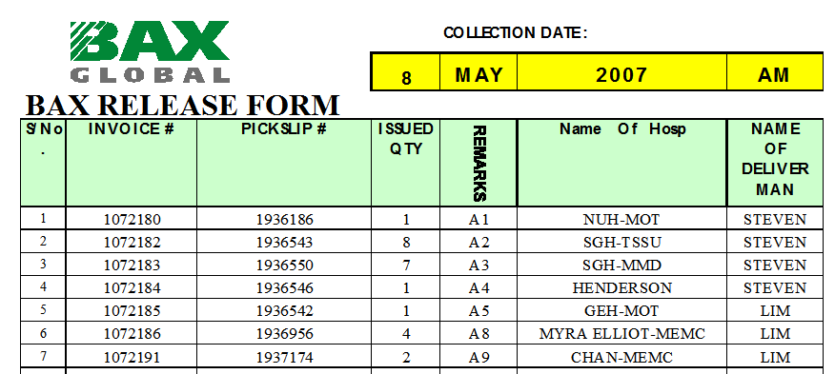

- ASN screen

To allow default “Exterline#” from ASNline# during creation of ASN, ops still can over write the “Exterline#” as well.

